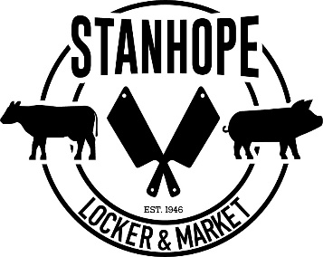
Lamb/Goat Order Forms
Tracking # :______________
Livestock Provider : ________________
Customer : __________________________ Phone : ________________
Date of order :_______________ Pick up Date : ________________
Product Requests:
Leg Roast: Y or N  OR  Leg Steaks | Neck Sliced  OR  Neck Roast
Shoulder Roast: Y or N  OR  Shoulder Steaks | Shanks: Y or N
Chops:  Y or N | Specific Cuts:
Ribs:
Y or N
Ground OR Stew Meat
WE WILL TEXT YOU WHEN YOUR ORDER IS READY! THANKS
Total: $175 WHOLE
$90 HALF

